

LIMITED

LIABILITY COMPANY

**LASERTAG**

SPECIFICATION

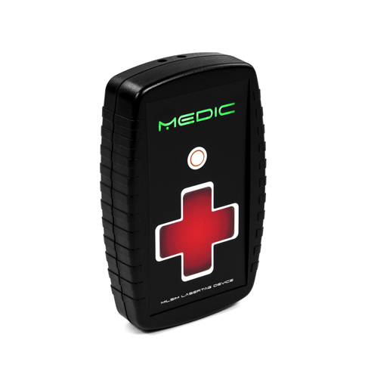

**Game set**

**Medic**

Smolensk

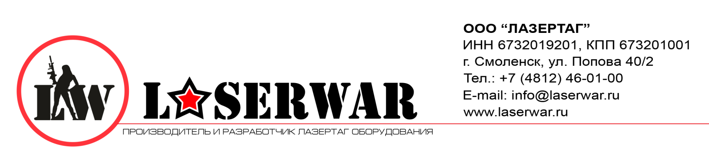

Dear Customer!

Our company welcomes and thanks you for the decision to buy our products, and is confident that the purchased device will bring you a long-term pleasure. The warranty certificate establishes the guarantee of the product in the amount provided for by the Law on consumer protection of the Russian Federation.

This warranty certificate is valid for 12 months from the purchase date of the product, and is subject to the guarantee terms.

Warranty Terms:

1. The guarantee is effective upon presentation of this coupon, which shall contain the serial number of the product and the date of its purchase, confirmed by the service centre.

2. These guarantee obligations apply to products acquired only from the official LASERTAG representative or the official dealer.

3. The present guarantee is invalid if the product deficiencies have occurred in the following cases:

- failure to comply with Operating instructions;

- mechanical damage;

- penetration of extraneous items, liquids, etc.;

- animal activities;

- unauthorized access to the parts of the game set by non-authorized persons;

- use of the product for purposes for which it hasn't been made;

- Acts of elements (natural disaster, fire, accidents, etc.);

- the game set malfunction in case of faulty power network and/or poor care of the product.

4. If the warranty certificate is lost, no duplicate is issued.

buttons for restoring health and replenishing ammunition, a power LED, IR diode.

**6. Maintenance**

All parts of the set must be treated with care if you want the equipment to function properly. Protect the IR emitters from mud. There shouldn't be any moisture inside the frame. Replace the batteries when needed. Don't hit the device.

**7. User's manual**

Customize game settings through the lasertag-configurator. To enter the programming mode, place the device next to the USB base so that the sensors of the devices are located opposite each other. Then run the "New Game" option using the remote console. You will enter the mode in ten seconds. The LEDs will light up purple.

Having changed the settings, press the "write" button. Now the device is ready for use.  
Note: if you reinsert the batteries, you will need to run "New Game" command using the remote console. This is called "a memory effect". The device saves the programmed parameters.

**8. Changing characteristics**

Changing device settings is not supported.

6

3

**9. Guarantee obligations**

The manufacturer guarantees the reliability of the operation of an individual LASERWAR set if the consumer has complied with the conditions of use. Technical support is provided within **12 months** of the sale date. The manufacturer undertakes to replace or repair an individual set of equipment free of charge, if the customer has complied with the rules for the device transportation, storage, operation and delivery of defective equipment to Smolensk City.

**10. Contact information**

**Official website:**

www.laserwar.ru

**E-mail:** Purchase Date: _________________________

info@laserwar.ru

support@laserwar.ru

**Skype:**

info-laserwar.ru

support laserwar.ru



______________________________________

**Equipment Maintenance Rules**

***1. Weather conditions.*** At the course of manufacture, we make different tests to see how well the equipment works under different weather conditions. Despite this, we strongly recommend that the equipment shouldn’t be used in the rain and at temperatures below -20 ° C.

What should I know when using the equipment in poor weather conditions?

The most important thing is to avoid getting moisture inside the device. If this happened, turn off the device, dry the equipment at room temperature for at least two hours.

***2. Power source.*** The device uses 9V lead acid batteries. Don't forget to replace the batteries in time.

It is necessary to store the equipment in a well-ventilated room at temperature from + 18°C to + 30°C and relative humidity of 45-65%.

**The warranty is 14 days for batteries, speakers, and IR modules. These components are expendable materials.**

**PLEASE NOTE! In the case of improper operation of the accumulator (charging by an unrelated type of a charger), the warranty doesn't cover the battery!**

5

4

**1. Description**

The Medic game set is a device that helps to restore health points, replenish ammunition and change other parameters during the game. A teammate can become a medic, as well as a player without any weapon at all.

**2. Scope of application**

The device is designed for remote health recovery, replenishing ammunition and changing game settings. It is used in organizing laser tag activities, tactical training, corporate and entertainment activities.

**3. The set includes:**

1. Medic - 1 pc.
2. Specification - 1 pc.

**4. Basic technical Data**

|  |  |
| --- | --- |
| Height, mm | **145** |
| Width, mm | **90** |
| Thickness, mm | **32** |
| Voltage | **6** |
| Number of IR emitters, pc | **1** |
| Wavelength of infrared radiation, nm | **940** |
| Weight, kg | **0.23** |

**5. Device**

The medic game set has a plastic frame of black color. Inside the frame there are batteries, clamping elements.

Information on the repairs performed during the maintenance period (completed by the Service centre performing the warranty repair works).

|  |  |
| --- | --- |
| **Date**: __________________  **Completed work:** _____________________________________________________________________  **Service centre stamp** | **Date**: __________________  **Completed work:** _____________________________________________________________________  **Service centre stamp** |
| **Date**: __________________  **Completed work:** _____________________________________________________________________  **Service centre stamp** | **Date**: __________________  **Completed work:** _____________________________________________________________________  **Service centre stamp** |
| **Date**: __________________  **Completed work:** _____________________________________________________________________  **Service centre stamp** | **Date**: __________________  **Completed work:** _____________________________________________________________________  **Service centre stamp** |

7

2